High-Level Design (HLD)

Real-Time AI Fraud Detection System — Proof of Concept

1. Overview
A real-time fraud detection system that ingests streaming transaction events, scores them with an ML model, and takes action (block / flag / allow) within milliseconds. This is a demo / proof-of-work build.

2. Goals & Non-Goals

Goals
- Detect fraudulent transactions in real time
- Handle streaming (simulated live) data
- Provide a live dashboard for demonstration
- Show model accuracy (precision / recall)

Non-Goals
- Production-grade security & compliance
- Multi-region deployment
- Real payment gateway integration

3. High-Level Architecture

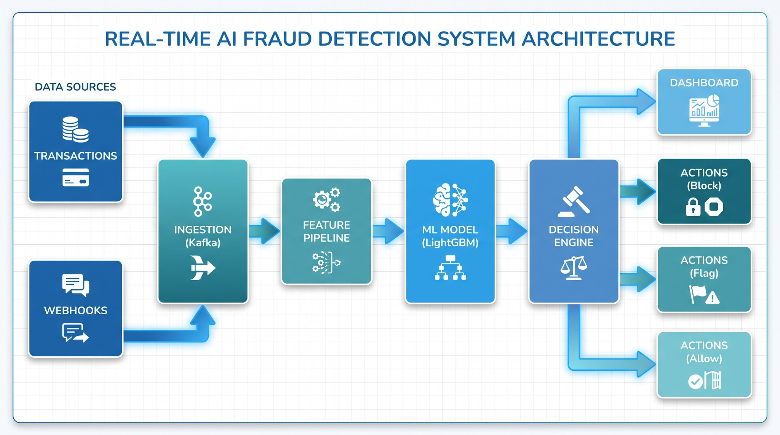

4. Components

Component | Responsibility
Data Sources | Transactions, webhooks, user events
Ingestion | Kafka / Python generator — streams events
Feature Pipeline | Computes velocity, amount, device, IP features
ML Model | LightGBM/XGBoost — scores fraud probability
Decision Engine | Applies threshold → block / flag / allow
Dashboard | Live feed, alerts, metrics

5. Data Flow
- Transaction event arrives via ingestion
- Feature pipeline computes real-time features
- ML model returns fraud probability
- Decision engine applies threshold
- Action taken (block / flag / allow) + logged
- Dashboard updates in real time

6. Technology Stack
- Streaming: Kafka (optional) / Python generator
- Model: LightGBM / XGBoost
- API: FastAPI
- Dashboard: Streamlit
- Storage: PostgreSQL

7. Key Design Decisions
- Start with a Python generator replaying a public dataset (no Kafka needed for v1)
- Use precision/recall over accuracy (class imbalance)
- Fail-open fallback if the model errors
- Log explainability for every decision

8. Risks & Mitigations

Risk | Mitigation
Class imbalance | Use precision/recall, resampling
Model drift | Monitor & retrain loop
Latency | Lightweight model, fast API
False positives | Tunable threshold

